42nd Street Tap Ballet

- Victor – Robber – Dancer to provide black jazz pants and black turtleneck
- Abbie S. – Peggy Sawyer – Blue Dress provided by ADT
- Nathaniel – Main Sailor – ADT will provide shirt, tie and hat, dancer to provide black dress pants.
- Jack & Sherrod – Sailors ADT will provide shirt, tie and hat, dancer to provide black dress pants
- Lily Rich & Lily Size – Tap Girls – Dancer to provide pink Singing in the Rain dresses
- Ella, Kaitlyn, Grace – Sexy Ladies - 2018 Green, blue, black recital costume. Please find one.
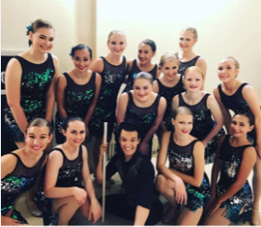
- Madison, Janie, Katherine – Little Niftys - Provided by ADT
- Baylee & Maggie – 2019 Advanced Class Recital Costume. Please find one.
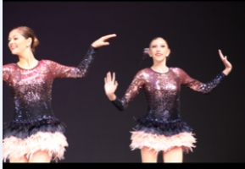
- Morgan & Schuyler - Bell Hops – Provided by ADT
- Ryan – Cop - Dancer to provide blue button shirt and black dress pants. Accessories provided by ADT.

